A Brief guideline of Bambu Studio
Because the majority of 3D printers in LBL are from Bambu (拓竹), this document provides a brief guideline on how to use them.

Model
There are two different printer models in LBL: Bambu Lab H2S and Bambu Lab P2S.
Before using, you should choose the right model.
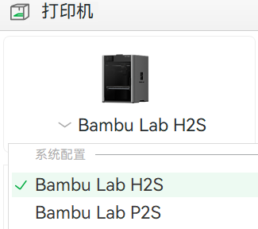

Settings
You shouldn’t change any initial settings of the machine, except the nozzle diameter, which should be set to 0.4(mm).
To make your prints lighter or stronger, you can change the infill density.
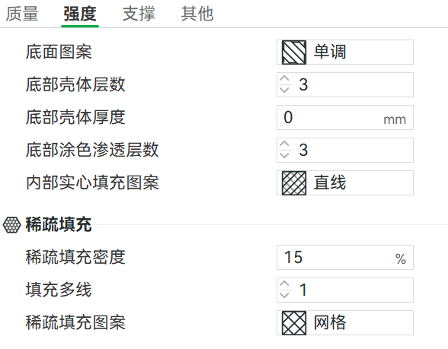

If the part has many overhangs, you can enable supports.
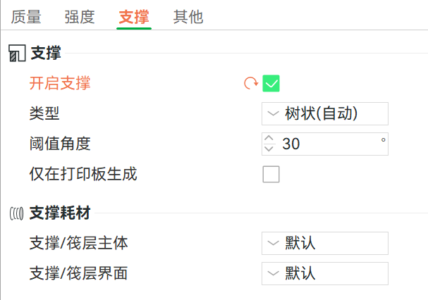

Slicing
Before importing your 3D models into Bambu Studio, you should save them as .STL files, which you can do it in SolidWorks.
Click “Files--Import--Import 3MF/STL” and choose the STL file you just saved. You can repeat this to add and slice many parts in the same time.
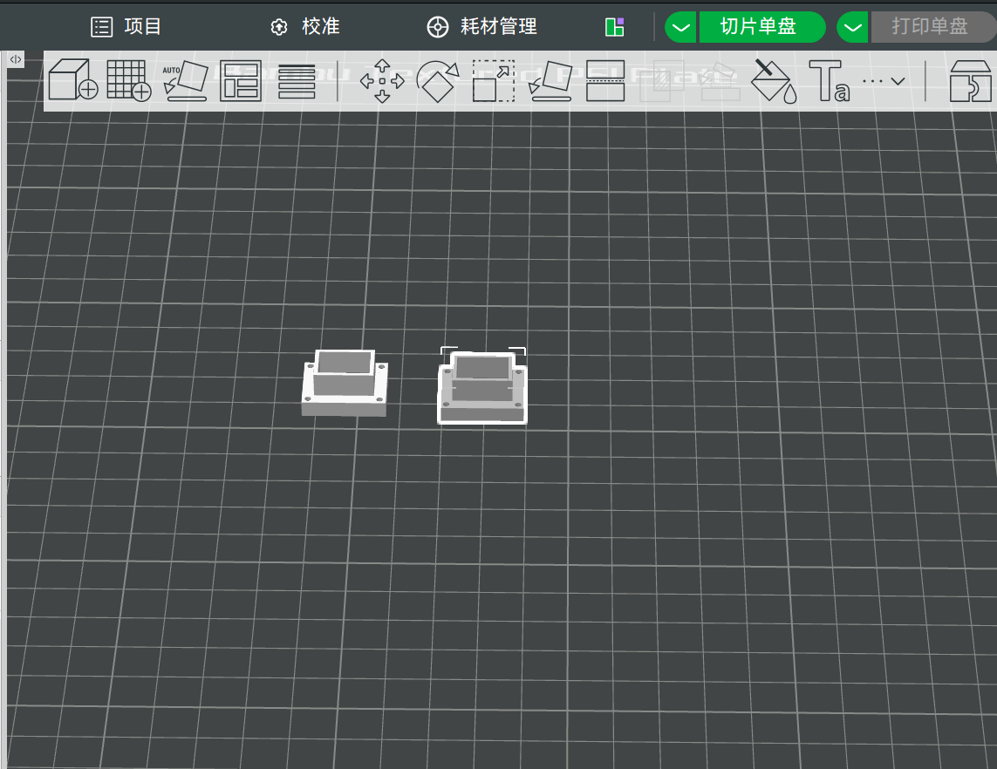

Adjust the position of the parts with the mouse and the buttons above.
Then click “Slice” and choose “Export single-plate slice file”.
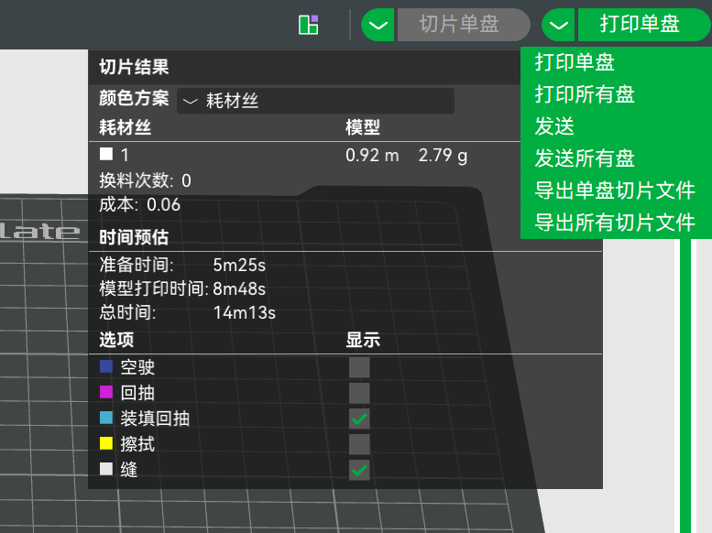
Then you will get a .gcode.3mf file. Copy it onto a USB flash drive (its capacity shouldn't be too large), and transfer the file to the 3D printer to print.

